ksmqK;dj 2

2' 1 **iajNdúl p,k**"" **ks¾ñ; p,k ";d,dkql+, p,k**

fï wkqj m%Odk jYfhka p,k ;=kla y÷kd.; yel' tkï

**iajNdúl p,k" ks¾ñ; p,k iyd ;d,dkql+, p,k fõ'**

tosfkod PSjsf;a wdhdihlska f;drj isoq lrk p,khka **iajNdúl p,k** fõ'ñksiqka yd i;=ka ;=, Wmf;a isg p,kh olakg ,efí' ;j oqrg;a meyeos<s lsrSfïoS fuu p,khka wm PSj;ajkúg idudkHfhka isoqjk YrSrh fi,ùuhs'

ksoiqka f,i**" weúsoSu osùSu'**

**my; rEm igykska meyeos<sj yoqkd.; yel'**

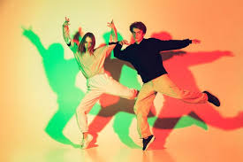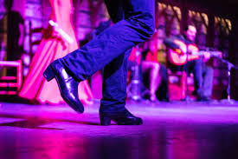

**ks¾ñ; p,k**

iajNdúl isoqjk p,k ks¾udKYS,Sj bosrsm;a lsrSfuka **ks¾ñ; p,k** ìys fõ' ks¾us; p,k ;=, mrsl,amk Yla;sh .eí ùwe;'

ksoiqka f,i" **idudkH wdldrfhka weúSoSug fkdyelsnj fmkajSu**  **my; rEm igykska meyeos<s fõ'**

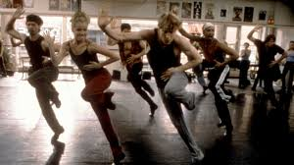

**;d,dkql+, p,k** iajNdúl p,k yd ks¾añs; p,k fhdod .ksñska **;d,dkql+, p,k** ks¾audKh l< yel' fuu.ska isoqjkafka lsishïa rsoauhlg wkqj ;u isrer p,kh lsrSuh's

"**ix.S; lKavhlg wkqj k¾;kfha fhoSu'**

**my; rEm igykska meyeos<s fõ'**

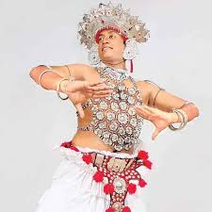

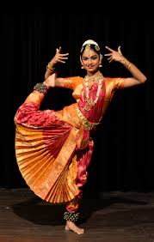

wNHdi

01 m%Odk p,k ;s%;ajh kï lr tu ;s%;ajh wod<j ksoiqka ;=k ne.ska ,shd olajkak' 02 fõosld kdgHhl rEmK ls%shdj,sfhaoS p,k jeo.;ajk wdlrh fláfhka olajkak'