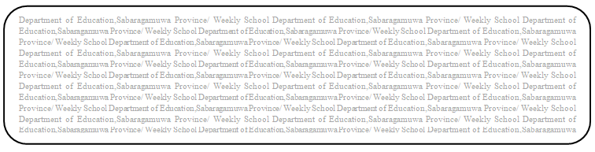

jdrh - m<uq

සංගීතය

fYa%Ksh - 13

m<d;a wOHdmk fomd¾;fïka;=j inr.uqj - i;s mdi,a

නයනා උපමාලි

**ld¾h m;%sldj 06**

* **ksmqK;djh (** jdoH NdKavhkays iajrEmh jgyd .ksñka jdok yelshdj m%o¾Ykh lrhs¡
* **mdvu (** String, Wind, Percussion isoaOdka;h yd mdi,a moaO;sfha Ndú;d jk ix.S; NdKav

y÷kd.ekSu

* **bf.kqï M, (** ⦁ String, Wind, Percussion hk j¾. j,g wh;a NdKav kï lrhs¡

⦁ mdi,a moaO;sfha tu NdKav Ndú; jk nj ms<s.kS¡

⦁ NdKav ,ehsia;=.; lrhs¡

* **YsIHhd l< hq;= ld¾hhka**

⦁ ngysr l%uhg jdokh lrk ix.S; NdKavhla iys; ùäfhda o¾Ykhla krUkak¡

⦁ ngysr ;ka;%Sh NdKav" Y=Isr NdKav iy iu>d; NdKav ms<sn| kï ,hsia;=jla ilikak¡

⦁ ngysr ix.S; NdKav j¾.SlrKh iys; j.=jla ms<sfh< lrkak¡

* **by; l%shdldrlï i|yd i|yd Wmldr lr .; yels websites**

⦁ www.nie.lk - fmrÈ. ix.S;h w;sf¾l lshùï fmd; 13 fYa%Ksh ^msgq 22 - 27&

⦁ <https://youtu.be/tFdlhlmQ-ek>

⦁ <https://youtu.be/auDkIQ5wEyQ>

⦁ <https://youtu.be/5UZ-eegmiNs>

⦁ <https://youtu.be/NJqtIyBiJ40>

⦁ <https://youtu.be/6PYammVOr8s>

* **we.hSï**

⦁ ngysr ix.S; NdKav j¾.SlrKh olajkak¡

⦁ Brasswind Instruments j,g wh;a ix.S; NdKav 3la kï lrkak¡

⦁ mdi,a moaO;sh ;=< Ndú; jk wmrÈ. ix.S; NdKav ,ehsia;=jla ms<sfh, lrkak¡

* **miq l%shdldrlï**

ngysr ix.S; NdKav j¾.SlrKh wkqj wod< ix.S; NdKav j, rEm igyka f;dard oDYH WmlrKhla ilikak¡