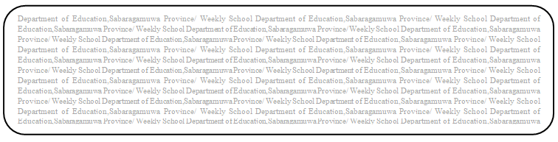

පළාත් අධHdපන දෙපාර්තමේන්තුව සබරගමුව - සති පාසල

විෂය :- ප්‍රායෝතික තාක්ෂණ කුසලතා
fY%Aණිය :- 8 ශ්‍රේණිය
Prepared by -
සතිය :- දෙවන සතිය
PROVINCIAL DEPARTMENT OF EDUCATION – WEEKLY SCHOOL

SUBJECT :- HEALTH AND PHYSICAL EDUCATION
GRADE :- 08
CREATED BY : – ZONAL EDUCATION OFFICE,
EMBILIPITIYA
WEEK :- 3RD
WEEK
1. Write 3 of suitable health related policies which help to promote health in your school.

2. Write 4 of your life skills that help to build a health promoting school.

3. Write 2 of Progrmmes or activities that can be contribute by community to school for health promotion.

4. Write 4 of institutions and personals which help to maintain and promote you and your school.

5. Write 3 of health services provided by institutions

